Results and Comment:

1. Results

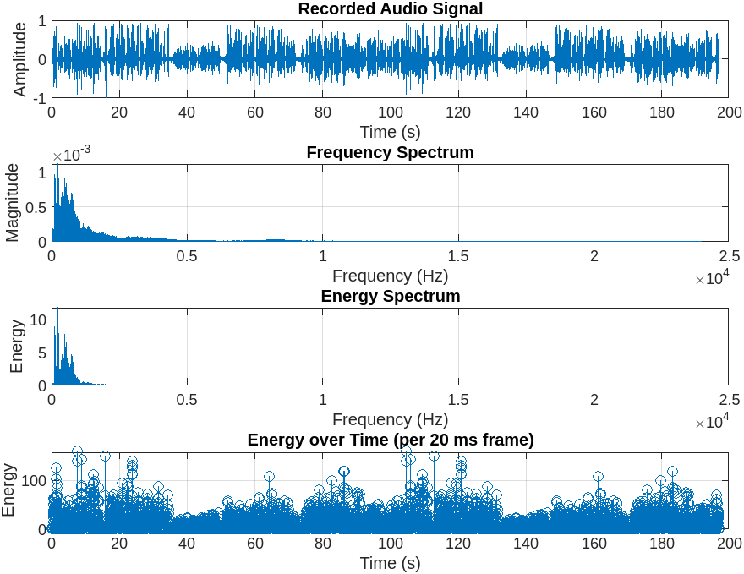

1. Comments:

The audio signal, lasting around 200 seconds and normalized between -1 and 1 in amplitude, shows clear segments of strong and weak (or silent) activity in the time domain. This intermittent pattern suggests the presence of speech or conversational content, with natural pauses between phrases.

In the frequency domain, the amplitude spectrum reveals that most energy is concentrated in low frequencies, particularly below 2 kHz. Frequencies above 5 kHz contribute very little, indicating the absence of high-pitched sounds like metallic instruments or high-frequency noise.

Energy spectrum analysis, based on the squared amplitude, confirms that nearly all signal energy lies in the 0–2 kHz range. This aligns with the typical frequency range of human speech (300 Hz to 3.4 kHz), making the signal well-suited for voice processing applications.

The short-time energy plot (20 ms frames) shows clear energy variations over time, with recurring peaks corresponding to voiced segments and low-energy regions representing silence. This is useful for tasks like speech segmentation and Voice Activity Detection (VAD).

In summary, the signal displays typical characteristics of human speech: low-frequency dominance and temporal variation. These insights support targeted processing strategies such as low-pass filtering, feature extraction, and efficient compression focused on the informative frequency range.